# CS 255 System Design Document Template

This template lays out all the different sections that you need to complete for Project Two. Each section has guidance to prompt your thinking. You will need to continually reference the interview transcript as you work to make sure that you are addressing your client’s needs. There is no required length for the final document. Instead the goal is to complete each section based on what your client’s needs are. Remove this note when you are finished, and replace all bracketed text with the relevant information.

## UML Diagrams

### UML Use Case Diagram

### UML Activity Diagrams

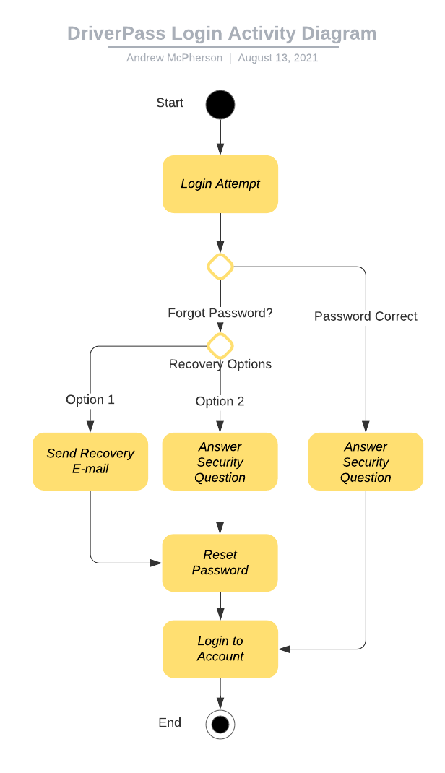

### UML Sequence Diagram

### UML Class Diagram

## Technical Requirements

*[Based on the diagrams you have created, describe the technical requirements of your system. These requirements should address the required hardware, software, tools, and infrastructure necessary for your system design.]*

Some of the technical requirements for this system will require a database of some kind, that not only stores all the information for each customer, but also all appointment dates and records for past tests and so on.  
Of course since DriverPass is supposed to be a web-based application this will require a server host (or cloud) to run the app for use and need to be online and available at all times (or nearly constantly at least). This will require the users to have access to a computer or mobile device with web browser capabilities.

Also, based on previous discussions of requirements and above diagrams, there are other requirements of security, such as password protection (like security questions and password recovery e-mails) that should be in place.

As for tools, at least for the development of this app tools like Azure boards to track the progress of how the app is being developed, and what tasks need completion would be a recommended choice when developing this system.

For Infrastructure, I believe would fall under the use of Cloud Servers, as this was desired to be on cloud, the use of a cloud service would be required.